**DIGM-243: Web Authoring II**

**Week 07**

**Plugins, Widgets, Menu Systems, Galleries and jQuery, Oh My!**

One of the great things about WordPress is how customizable it is. Not only with the options that are available in the dashboard with the standard installation, but the system has been developed to be customizable via your own functions (which we looked at last week) or by utilizing plugins developed by other programmers.

**Plugins:**

WordPress plugins are similar to Adobe PhotoShop plugins in that they can extend the functionality of WordPress almost without limit. In the WordPress plugin Directory ( <http://wordpress.org/extend/plugins/> )you can find, download, rate, and comment on all the best free plugins the WordPress community has to offer. There are other sites that offer free and commercial plugins. To many plugins can slow your WP site down to a crawl, and unsupported plugins can "break" at any given WP update, so choose your plugins wisely.

plugins are always being updated, some developers stop supporting their plugins, some plugins stop working with new WP updates, and sometimes better plugins come along that then fall into this routine. This is how an OpenSource community works.

Wordpress recently released the **Jetpack** plugin, a way to supercharge your WordPress site with powerful features previously only available to WordPress.com users.

One of Jervis' favorite plugins is WP Antivirus, it's free, easy to use and effective. <http://wpantivirus.com/>

There are three basic ways to install plugins. You can upload the plugin folder via FTP into wp-content/plugins. From inside the dashboard/plugins you can click Add New, and you will have the ability to upload a plugin .zip file, or you can search the WP plugin Directory and let the system take care of everything for you.

Once the plugin is installed you can activate it via the main plugin screen. Here you can also deactivate any active plugin, edit, delete and deactivated plugin, and sometimes there will be a link to a plugins settings screen.

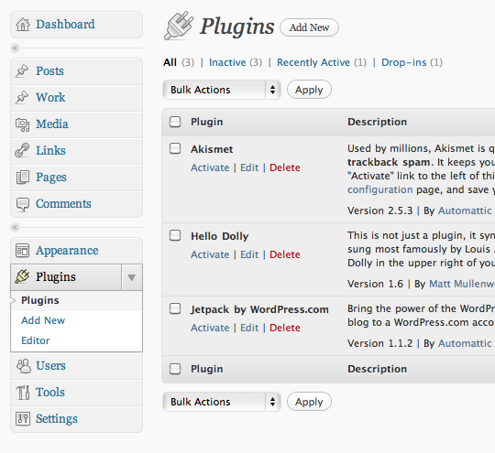

**Widgets:**

WordPress Widgets (WPW) allow you to organize different elements of your web site into sidebars easily a.k.a. drag and drop, no coding. You can think of widgets as mini-plugins. In fact, most widgets are activated via plugins. Some plugins add widget functionality that match or extend their purpose, some don't, and some only add widget functionality.

You will find these in the Dashboard Appearance Menu -> Widgets. This window is controlled by basic drag and drop functionality. Just drag the widget of your choice from the Available Widget are to the Sidebar of your choice. Or drag the widget out of the sidebar back to the Available Widgets area to deactivate. Most widgets have extra functionality that can be accessed once placed into the sidebar via the down triangle in the Widget's title bar.

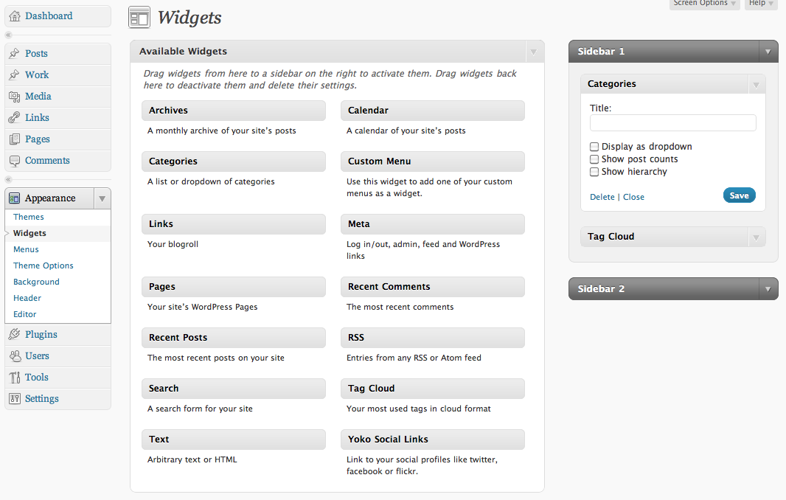

Jervis uses the "Tag Cloud" widget on all of his WP sites. It gives your users an easy way to see what is trending on your site.

**Essential(?) plugins**

Everyone and their mother have opinions on what constitutes an essential WordPress plugin (try googling it), but while a lot of these are tantalizing and tasty looking, you want to make sure that you do not fall into the plugin overload trap as previously mentioned. The more plugins you add the slower your site will run. Make sure that there is a strategic need for every plugin that you add to your site. It is also good to note that some plugins add tables to your database, so it is wise to set up a sandbox site for testing purposes then only implement the plugins on your main site that you know you will need so that you do not end up with database bloat due to tested and abandoned plugins.

Here is a list of just a few of the more popular plugins:

WP Greet Box

Yet Another Related Posts plugin

Popularity Contest

WP-PostRatings

WP-Polls

NextGen Gallery

jQuery LightBox

Featured Content Gallery

WP No Category Base

WP No Tag Base

WP-DB-Backup

Maintenance Mode

Shockingly Big IE6 Warning

Branded Admin

Theme My Login

Google Analyticator

Google Analytics for WordPress

WordPress.com Stats

Broken Link Checker

Redirection

WordPress Download Monitor

More Fields

Advertising Manager

Members Only

Random Redirect

TinyMCE Advanced

Custom Post Type UI

Widget Context

Members

Askimet

WP-SpamFree Anti Spam

TypePad AntiSpam

Really Simple CAPTCHA

Cookie for Comments

WP-HashCash

Twitter Tools

Share This

Add to Any

Wickett Twitter Widget

Twitter for WordPress

Sociable

Mobile Press

WordPRess Mobile Edition

WPTouch

All in One SEO Pack

Google XML Sitemaps

Better Search

Robots Meta

Google Translator

Breadcrumbs Trail

SyntaxHighlighter Evolved

WP-Typography

Widget Logic

WP Super Cache

Query Posts

WP-DBManager

WP-PageNavi

**Menu Systems:**

WordPress menus are also available in the Appearance menu. Many WP themes will allow you build dynamic menus to replace the default menus. You can rearrange your menu items, have menu items link to your WP pages, categories, post, or even other web sites. You can have drop down menus on rollover; however, be caution of rollover drop down menus you plan on having many visitors to your site via mobile devices. More info on how to work with these can be found at http://codex.wordpress.org/Appearance_Menus_Screen

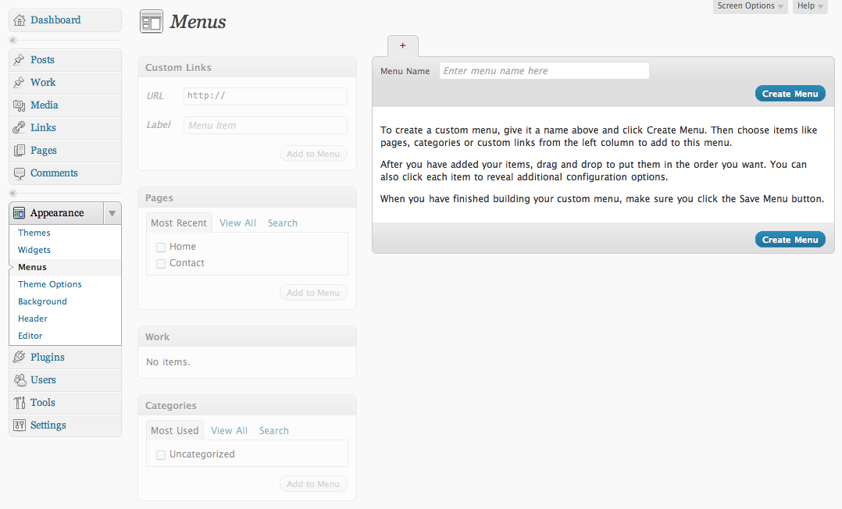

**Galleries:**

You can use built in gallery to upload your images, store them on your server, and show them to the world. http://codex.wordpress.org/Gallery_Shortcode

If you want more flexibility on how to display your images you can try one of the many plugins to customize your image page, thumbnails, and full size picture displays. Jervis uses "NextGen Gallery" and "WP-Slimbox2".

A third option would be to use a plugin to integrate your Flickr and/or Picasa images into your WP gallery.

It is good to note that galleries only deal with still imagery.

**jQuery:**

jQuery has become very popular over the past few years. It is basically a collection (library) of javascript functions you can call that allows you to implement animation, ajax interactions, document navigation, etc into your web site. You can use jQuery within Wordpress; however, it can be tricky. jQuery "$" functions can conflict with other libraries like Prototype which is used by WP.

For more research on this I would recommend:

**WordPress 3.0 jQuery**

by: Tessa Blakeley Silver

Packt Publishing (September 24, 2010)

ISBN#9781849511742

**In-Class exercise:**

Add the following to your WP site if you have not already done so:

* At least one plugin and customize it via it's built in options
* At least one widget to a sidebar and customize it via it's built in options
* Build a custom menu that links to more than just pages on your site.

---

**Homework**

**Read:**

**Professional WordPress: Design and Development**

Chapter 2 - Functional Overview

+ EXTENDING WORDPRESS

**Build:**

Continue working on coding your theme.

Bring your files to class for review.

Be able to show your instructor what progress you have made on your lists:

* Changes you believe you will be able to make in the Dashboard.
* Changes you believe you will be able to make in CSS.
* Changes you believe you will have to make with PHP.

**Submit:**

N/A

**[Instructor NOTE: Check it see if students have made progress, if students has NOT made progress ask them why, offer assistance (during class lab time), and remind him/her that their final project is the Majority of their grade for the class]**